

FACULTY OF ENGINEERING AND TECHONOLOGY

COMPUTER PROGRAMMING

**ASSIGNMENT REPORT ON APPLICATION OF KNOWLEDGE OBTAINED FROM MODULES ONE TO THREE MAINLY BASED ON TABLES AND STRUCTURES USING MATLAB**

BY GROUP SIX

PRESENTED TO MR. MASERUKA BENEDICTO

DATE OF SUBMISSION;

23rd SEPTEMBER,2025.

GROUP SIX MEMBERS

|  |  |  |
| --- | --- | --- |
| NAME | COURSE | REG NUMBER |
| OPIO SAM ODWORI | WAR | BU/UP/2024/4454 |
| MUWAZA DEOGRATIUS | PTI | BU/UP/2024/5398 |
| KATUNGUKA EMMANUEL | WAR | BU/UP/2024/1030 |
| JOAN RACHAEL LAGU | WAR | BU/UP/2024/1028 |
| KISAKYE PRISCILA PATIANCE | WAR | BU/UP/2024/1034 |
| AYOO LINDA | AMI | BU/UP/2024/5097 |
| WAMBASA GEOFERY | WAR | BU/UP/2024/3259 |
| NAMANYA PRECIOUS | AMI | BU/UP/2024/5255 |
| NANGOLI DERRIK | AMI | BU/UP/2024/3736 |
| APUDA CECILIA LINDI | WAR | BU/UP/2024/3248 |

## DECLARATION

We group six members declare that all the work embodied in this report is of our own efforts and that it was not duplicated from any.

|  |  |
| --- | --- |
| NAMES | SIGNATURE |
| WAMBASA GEOFREY |  |
| OPIO SAM ODWORI |  |
| JOAN RACHAEL LAGU |  |
| KISAKYE PRISCILA PATIENCE |  |
| NAMANYA PRECIOUS |  |
| AYOO LINDA |  |
| KATUNGUKA EMMANUEL |  |
| MUWAZA DEOGRATIUS |  |
| APUDA CECILIA LINDI |  |
| NANGOLI DERICK |  |

## ACKNOWLEDGEMENT

We thank the Almighty God for the gift of life, knowledge and constant guidance throughout the course of this assignment. We extend our sincere gratitude to our beloved parents for their support in our academics and also our lecturer Mr. Maseruka Benedicto (HOD) for his continuous efforts in ensuring we learn computer programming thoroughly.

We finally thank our fellow group six members for their cooperation and active participation in this assignment through our group leader Wambasa Geofrey.

## APPROVAL.

This is to confirm that this report has been prepared and presented by group six without duplication but research.

Date ……………………………………………………………

Signature……………………………………………………….

## DEDICATION

We dedicate this report to all group SIX members, who worked tirelessly to ensure that its completed.

## METHODOLOGY

We obtained our data (AI research past papers 2020-2024) from Kaggle.com in Excel format as a .csv file. We went ahead to save it as an excel work book xlxs. For easy transfer into MATLAB. We added the dataset file into our folder for convenience purposes, and proceeded with further processing. OUR destined task was to structure the data into separate years maintaining the structure of the individual year.

Table of Content

DECLARATION 3

ACKNOWLEDGEMENT 4

APPROVAL. 5

DEDICATION 6

METHODOLOGY 7

CHAPTER ONE 9

INTRODUCTION 9

HISTORICAL BACKGROUND 9

Historical Background 9

STUDY METHODOLOGY. 10

CHAPTER TWO: 11

Assignment one 11

CHAPTER TWO: 16

2.1 Assignment 2 16

CHAPTER THREE: 30

3.1 CHALLENGES 30

3.2 RECOMMENDATIONS 30

3.3 CONCLUSION AND LEARNING EXPERIENCE 30

## 

# CHAPTER ONE

# INTRODUCTION

## HISTORICAL BACKGROUND

MATLAB, which stands for matrix laboratory, is a high-performance programming language and environment designed primarily for technical computing. Its origins trace back to the late 1970s when Cleve Moler, a professor of computer science, developed it to provide his students with easy access to mathematical software libraries without requiring them to learn Fortran.

MATLAB is built around the concept of matrices, making it particularly effective for linear algebra and matrix manipulation. It provides a vast library of built-in functions for mathematical operations, statistics, optimization, and other specialized tasks.

MATLAB offers powerful tools for creating 2D and 3D plots, enabling users to visualize data effectively. Specialized toolboxes extend MATLAB's capabilities, providing functions tailored for specific applications like signal processing, image processing, control systems, and machine learning.

MATLAB can interface with other programming languages (like C, C++, and Python) and software tools, allowing for flexible integration into larger systems. Its interactive environment features a command window, workspace, and editor, making it accessible for both beginners and advanced users.

## Historical Background

The first version of MATLAB was created in Fortran in the late 1970s as a simple interactive matrix calculator. This early iteration included basic matrix operations and was built on top of two significant mathematical libraries: LINPACK and EISPACK, which were developed for numerical linear algebra and eigenvalue problems, respectively.

Recent versions of MATLAB have introduced features like the *Live Editor*, which allows users to create interactive documents that combine code, output, and formatted text. This evolution reflects MATLAB's ongoing adaptation to meet the needs of its diverse user base across academia and industry.

## STUDY METHODOLOGY.

### 

At the start, each member was given a task of making research about the assignment before our first meeting. The research concepts were obtained through watching tutorials on YouTube, reading the modules and

consultations from other continuing students especially those in year three and four.

## CHAPTER TWO:

# Assignment one

(a) There is a website called Kaggle.com, each group should be able to retrieve unique dataset in excel format. The group will read it in MATLAB in one code; they will be able to copy variables of each year and put them in the following;

i) Tables for each year of data.

ii) Convert the tables in (i) into structural arrays

iii) Output each of the variables in(ii) above into a single workbook with each year on separate sheets having clear columns headings and sheet names.

1. Each group has different members from different backgrounds, home districts, courses, religions, tribes, interests, ages, names and facial representation. Write a MATLAB code that can restore each members affirmation attributes into a single variable.

**Assignment one(a)**

**Brief summary about the question.**

For the first question, we retrieved a dataset, ‘AI-research paper 2020-2024’ from the website Kaggle.com in a .CVS format but then we converted it to excel format to be easily read in MATLAB.

We then read the excel file in MATLAB using the function ‘readtable.’

We proceeded to copy each variable into separate tables for each year. We then converted the tables into structural arrays for each year.

We were then able to output each of the variables into a single workbook with each year on separate sheets, with each sheet having column headings and sheet names however, we to do that, we had to first convert the struct table into tables for easy reading of the data in MATLAB.

Below are the codes;

% READING EXCEL FILE INTO MATLAB

T = readtable('ai_research_papers_2020_2024 (1).xlsx',ReadVariableNames=true)

% SEPARATING DATA FOR EACH YEAR INTO DIFFERENT TABLES

Y2020 = T(T.year == 2020, :);

Y2021 = T(T.year == 2021, :);

Y2022 = T(T.year == 2022, :);

Y2023 = T(T.year == 2023, :);

Y2024 = T(T.year == 2024, :);

% STRUCTURAL ARRAY TO HOLD EACH YEAR'S DATA

Y_2020 = table2struct(Y2020);

Y_2021 = table2struct(Y2021);

Y_2022 = table2struct(Y2022);

Y_2023 = table2struct(Y2023);

Y_2024 = table2struct(Y2024);

% CHANGING DATA FROM STRUCTURAL ARRAY INTO TABLE

Y_L_2020 = struct2table(Y_2020);

Y_L_2021 = struct2table(Y_2021);

Y_L_2022 = struct2table(Y_2022);

Y_L_2023 = struct2table(Y_2023);

Y_L_2024 = struct2table(Y_2024);

% OUTPUTING THE DATA INTO A SINGLE WORKBOOK

writetable(Y_L_2020,'ai_research_papers_2020_2024 (1).xlsx','Sheet',1);

writetable(Y_L_2021,'ai_research_papers_2020_2024 (1).xlsx','Sheet',2);

writetable(Y_L_2022,'ai_research_papers_2020_2024 (1).xlsx','Sheet',3);

writetable(Y_L_2023,'ai_research_papers_2020_2024 (1).xlsx','Sheet',4);

writetable(Y_L_2024,'ai_research_papers_2020_2024 (1).xlsx','Sheet',5)

Assignment 1(b)

**Brief summary of the question**

In this question, we were able to generate a code that enabled us to store each member’s affirmation attributes ‘background, home district, religion, course, tribes, interest, villages, ages, names and facial representation’ into a single variable and the code saved the variable.

Below is the codes;

% Member1

Member(1).Name = 'KATUNGUKA EMMANUEL';

Member(1).Age = 22;

Member(1).Course = 'WAR';

Member(1).HomeDistrict = 'NTUNGAMO';

Member(1).Village = 'MUTOJO';

Member(1).Tribe = 'MUNYANKORE';

Member(1).Background = 'HUMBLE';

Member(1).Interest = 'HAND BALL';

Member(1).Religion = 'ANGLICAN';

Member(1).FacialRepresentation = imread('PICTURES\WhatsApp Image 2025-09-20 at 17.12.33_69c6bcdd.jpg');

% Member2

Member(2).Name = 'APUDA CECILIA LINDI';

Member(2).Age = 25;

Member(2).Course = 'WAR';

Member(2).HomeDistrict = 'KATAKWI';

Member(2).Village = 'KATAKWI';

Member(2).Tribe = 'ATESOT';

Member(2).Background = 'RURAL';

Member(2).Interest = 'JOURNALING';

Member(2).Religion = 'ANGLICAN';

Member(2).FacialRepresentation = imread('PICTURES\WhatsApp Image 2025-09-20 at 17.14.07_6a72f7e0.jpg');

% Member3

Member(3).Name = 'OPIO SAM ODWORI';

Member(3).Age = 23;

Member(3).Course = 'WAR'

Member(3).HomeDistrict = 'MBALE';

Member(3).Village = 'MUTOTO';

Member(3).Tribe = 'SAMIA';

Member(3).Background = 'HUMBLE';

Member(3).Interest = 'FOOTBALL';

Member(3).Religion = 'BORN AGAIN';

Member(3).FacialRepresentation = imread("PICTURES\WhatsApp Image 2025-09-20 at 17.17.22_60b52dbd.jpg");

% Member4

Member(4).Name = 'MUWAZA DEOGRATIUS';

Member(4).Age = 22;

Member(4).Course = 'PTI';

Member(4).HomeDistrict = 'MASAKA';

Member(4).Village = 'KIMANYA';

Member(4).Tribe = 'MUGANDA';

Member(4).Background = 'HUMBLE';

Member(4).Interest = 'EATING';

Member(4).Religion = 'CATHOLIC';

Member(4).FacialRepresentation = imread('PICTURES\WhatsApp Image 2025-09-20 at 21.17.32_02888e4d.jpg');

% Member5

Member(5).Name = 'JOAN RACHAEL LAGU';

Member(5).Age = 21;

Member(5).Course = 'WAR'

Member(5).HomeDistrict = 'ADJUMANI';

Member(5).Village = 'CIFORO';

Member(5).Tribe = 'MADI';

Member(5).Background = 'HUMBLE';

Member(5).Interest = 'TOURING';

Member(5).Religion = 'CATHOLIC';

Member(5).FacialRepresentation = imread('PICTURES\WhatsApp Image 2025-09-21 at 10.58.31_a82be18b.jpg');

% Member6

Member(6).Name = 'AYOO LINDA';

Member(6).Age = 22;

Member(6).Course = 'AMI'

Member(6).HomeDistrict = 'ABIM';

Member(6).Village = 'OTALABAR';

Member(6).Tribe = 'KARAMOJONG';

Member(6).Background = 'HUMBLE';

Member(6).Interest = 'WATCHING';

Member(6).Religion = 'CATHOLIC';

Member(6).FacialRepresentation = imread('PICTURES\WhatsApp Image 2025-09-20 at 20.07.47_f66e8192.jpg');

% Member7

Member(7).Name = 'KISAKYE PRISCILA PATIENCE';

Member(7).Age = 21;

Member(7).Course = 'WAR'

Member(7).HomeDistrict = 'BUGIRI';

Member(7).Village = 'NKUSI';

Member(7).Tribe = 'MUSOGA';

Member(7).Background = 'HUMBLE';

Member(7).Interest = 'READING';

Member(7).Religion = 'CHRISTIAN';

Member(7).FacialRepresentation = imread('PICTURES\WhatsApp Image 2025-09-21 at 12.28.53_50ef1144.jpg');

% Member8

Member(8).Name = 'WAMBASA GEOFREY';

Member(8).Age = 25;

Member(8).Course = 'WAR'

Member(8).HomeDistrict = 'JINJA';

Member(8).Village = 'MASESE';

Member(8).Tribe = 'MUSOGA';

Member(8).Background = 'HUMBLE';

Member(8).Interest = 'ADVENTURE';

Member(8).Religion = 'CATHOLIC';

Member(8).FacialRepresentation = imread('PICTURES\WhatsApp Image 2025-09-20 at 19.47.32_ff7198c7.jpg');

% Member9

Member(9).Name = 'NAMANYA PRECIOUS';

Member(9).Age = 21;

Member(9).Course = 'AMI'

Member(9).HomeDistrict = 'WAKISO';

Member(9).Village = 'BUKEMBA';

Member(9).Tribe = 'MUNYAKOLE';

Member(9).Background = 'HUMBLE';

Member(9).Interest = 'READING';

Member(9).Religion = 'BORN AGAIN';

Member(9).FacialRepresentation = imread('PICTURES\WhatsApp Image 2025-09-21 at 01.21.28_3f590b06.jpg');

% Member10

Member(10).Name = 'NANGOLI DERICK';

Member(10).Age = 22;

Member(10).Course = 'AMI'

Member(10).HomeDistrict = 'BULAMBULI';

Member(10).Village = 'SAMAZI TCB';

Member(10).Tribe = 'GISHU';

Member(10).Background = 'HUMBLE';

Member(10).Interest = 'FOOTBALL';

Member(10).Religion = 'CATHOLIC';

Member(10).FacialRepresentation = imread('PICTURES\WhatsApp Image 2025-09-21 at 11.21.28_4acd8822.jpg');

save('assignment2.mat',"Member")

## CHAPTER TWO:

# 2.1 Assignment 2

1. From assignment one(a), utilize all knowledge obtained from 1-4 to visualize the different parameters, patterns, trends, and relationships. Ensure that each plot is saved as an image and all well labelled.
2. From assignment one(b) in assignment one, utilize all the knowledge statistical characteristics in data and ensure to visualize them. Ensure that the different attributes or data collected per individual is detained enough to describe them.

Assignment 2(a)

Codes and graphs

t = readtable('ai_research_papers_2020_2024 (1).xlsx');

Y2020 = t(t.year == 2020, :);

Y2021 = t(t.year == 2021, :);

Y2022 = t(t.year == 2022, :);

Y2023 = t(t.year == 2023, :);

Y2024 = t(t.year == 2024, :);

plot(Y2024.month,Y2024.citations);

xlabel('months');

ylabel('citations');

title("line plot of citations against months for 2024");

grid on

saveas(gcf,'C:\Users\user\Desktop\assignment\lineplot for 2024.png')

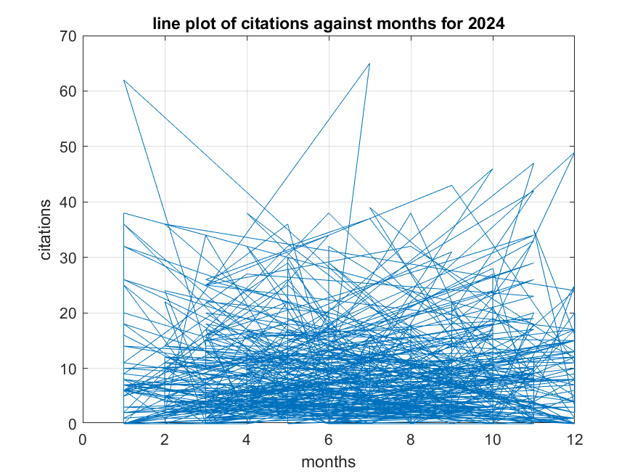

plot(Y2023.month, Y2023.citations,'g--o');

xlabel('months');

ylabel('citations');

title('line plot of citations against months for 2023');

grid on

saveas(gcf,'C:\Users\user\Desktop\assignment\lineplot for 2023.png')

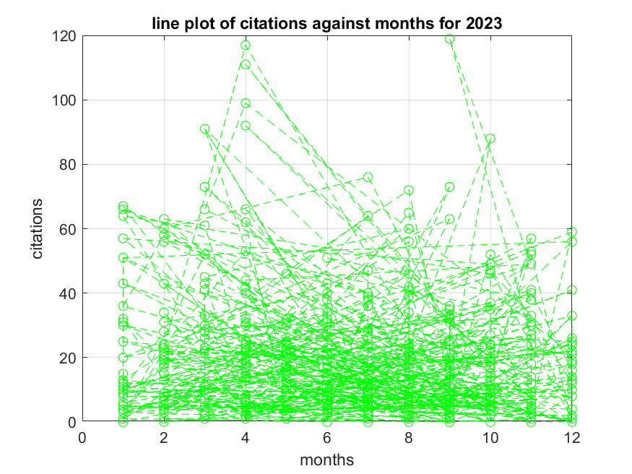

plot(Y2022.month,Y2022.citations,'--k');

xlabel('months');

ylabel('citations');

title('line plot of citations against months for 2022');

grid on

saveas(gcf,'C:\Users\user\Desktop\assignment\lineplot for 2022.png')

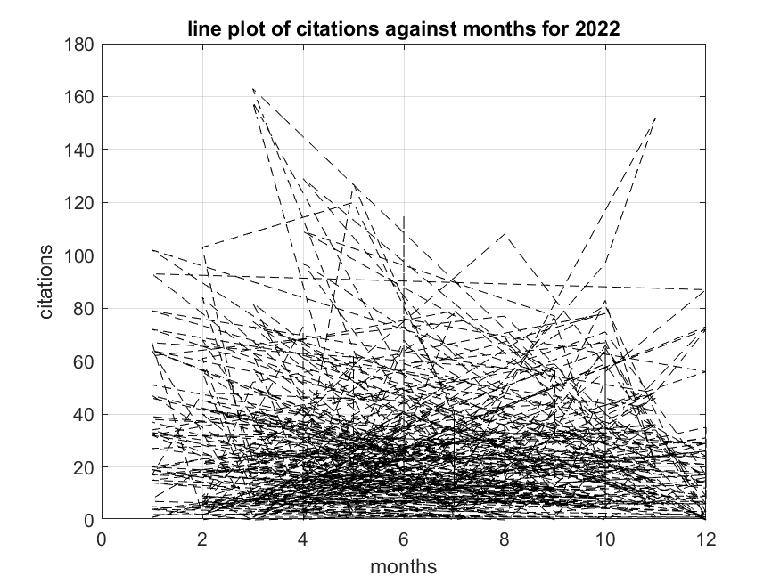

plot(Y2021.month,Y2021.citations,'--');

xlabel('months');

ylabel('citations');

title('line plot of citations against months for 2021');

grid on

saveas(gcf,'C:\Users\user\Desktop\assignment\lineplot for 2021.png')

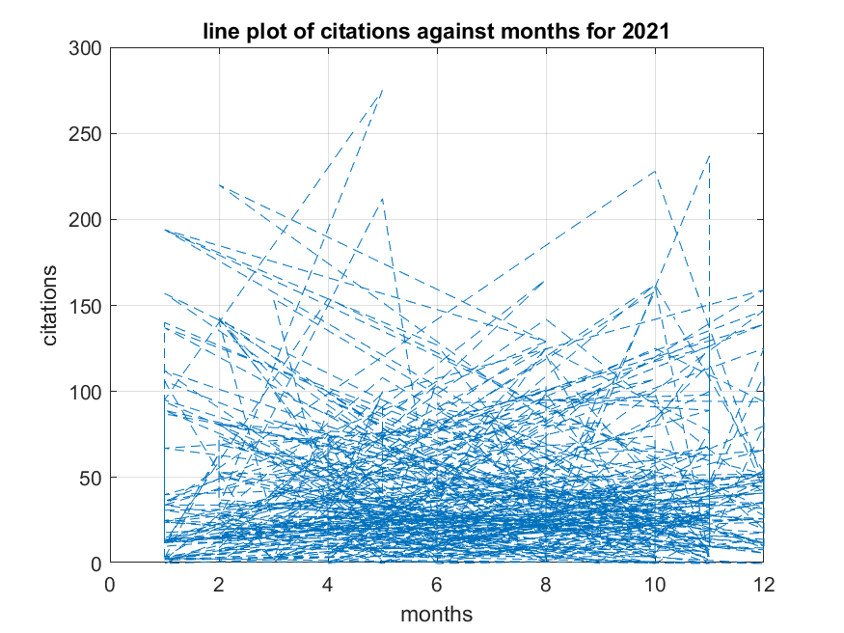

plot(Y2020.month,Y2020.citations,'--');

xlabel('months');

ylabel('citations');

title('line plot of citations against months for 2020');

grid on

saveas(gcf,'C:\Users\user\Desktop\assignment\lineplot for 2020.png')

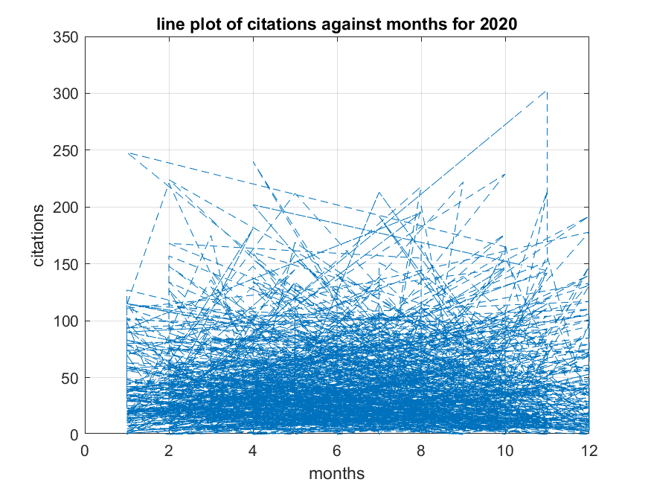

stem(Y2021.month,Y2021.page_length,'--g');

hold on

stem(Y2020.month,Y2020.page_length,'k');

hold on

stem(Y2023.month,Y2023.page_length,'--');

xlabel('months');

ylabel('page_length');

title('multiple stem plot ');

legend show;

hold off

grid on

saveas(gcf,'C:\Users\user\Desktop\assignment\multiple_stem_plot.png')

**A STEM PLOT OF PERCENTAGES AGAINST MONTH**

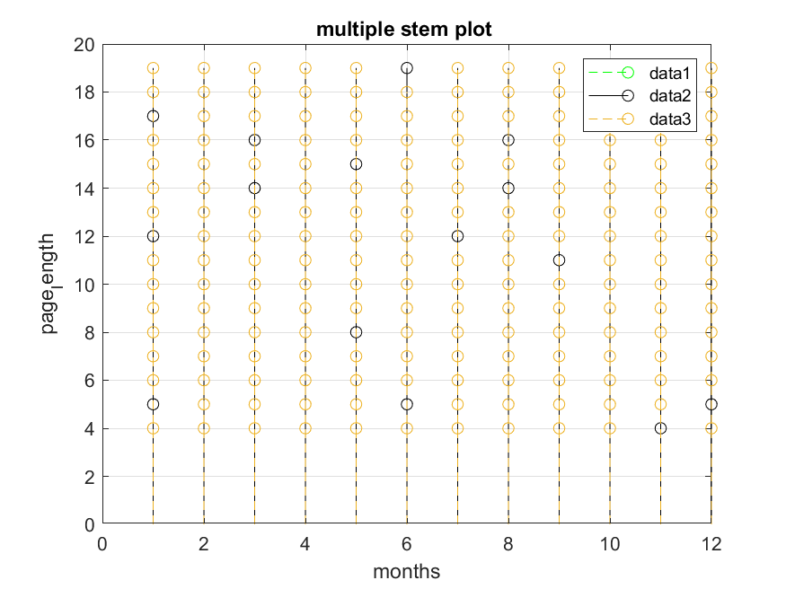

A multiple stem plots the data sequence ‘Y’ as stems that extend from the baseline along the X-axis

The data values are indicated by circles terminating each stem

x = (Y2021.month);

Y = sin(x);

stairs(x,Y,'g')

xlabel('month');

ylabel('sin(x)');

grid on

title('step plot');

saveas(gcf,'C:\Users\user\Desktop\assignment\_step_plot.png')

**A STEP PLOT OF MONTHS AGAINST SIN(X)**

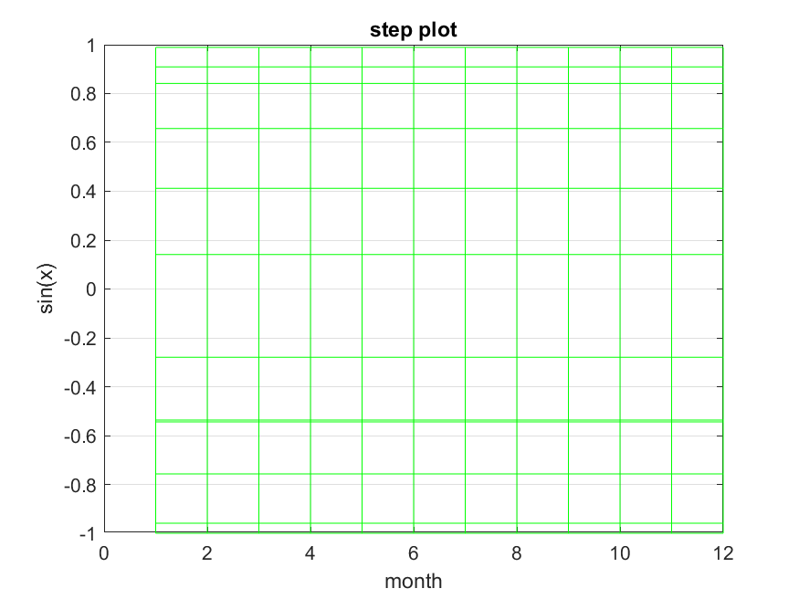

A step plot primarily displays a step response of a dynamic data which is a fundamental concept in control systems of engineering.

Assignment 2(b)

Codes and graphs

% converting the struct into table

D = struct2table(Member)

% Extract names and ages

Names = [D.Name];

Ages = [D.Age];

X = categorical(Names);

% plotting bar graph of Ages against Names

bar(X,Ages,'green')

xlabel('NAME');

ylabel('AGE');

title('AGES OF PEOPLE');

grid on

**A BAR GRAPH OF GROUP MEMBER NAMES AGAINST THEIR AGES**

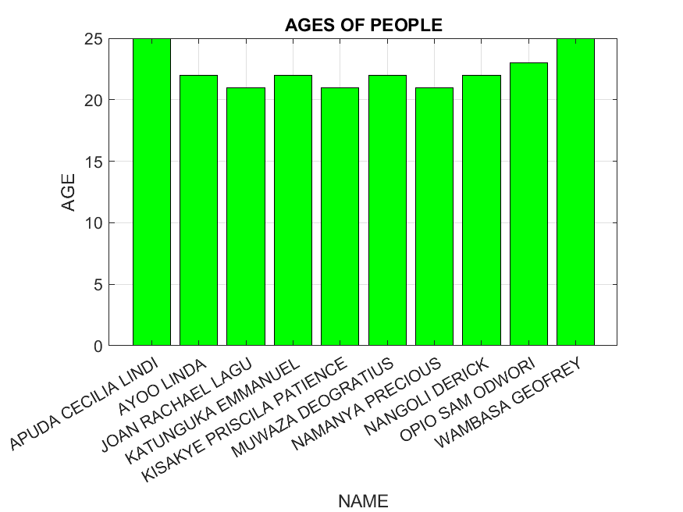

This creates and displays data for given elements; it specifies X and Y directions i.e. a plot of names against ages.

% Histogram for Age distribution

histogram(Ages)

title('Age Distribution')

xlabel('Age');

ylabel('Frequency')

title('Histogram of Ages');

grid on

**A HISTOGRAM SHOWING FREQUENCY AGAINST AGES**

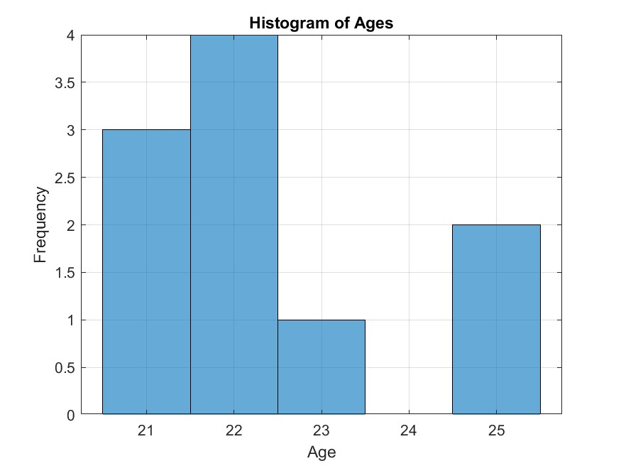

This displays and modifies discrete data in different assets by changing its property values as given. It is widely used in the different aspects of engineering.

% plot pie chart

Ages = [22,25,23,22,21,22,21,25,21,22];

Names = ["KATUNGUKA";"APUDA";"OPIO";"MUWASA";"LAGU";"AYOO";"KISAKYE";"WAMBASA";"NAMANYA";"NANGOLI"];

pie(Ages,Names)

title('pie chart showing students and their age')

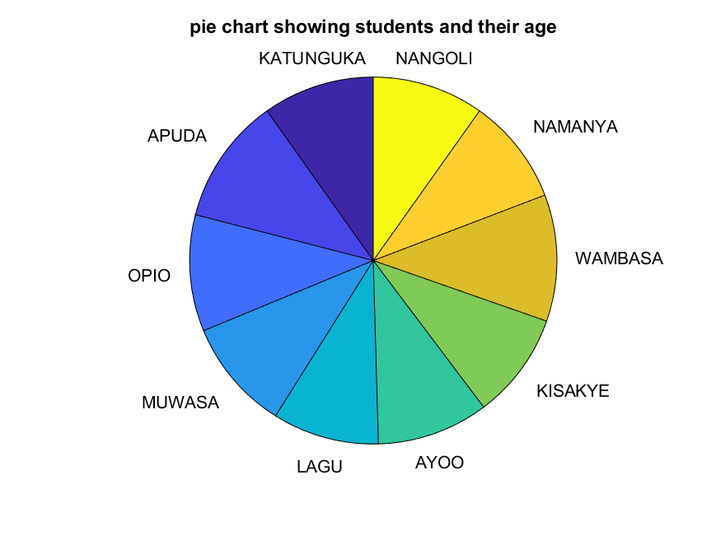

It is a circular graph that is divided into sections and each section represents a given proportion of the whole.

Courses = [D.Course]

Courses = {'WAR','PTI','AMI'};

Names = {'EMMANUEL','LINDI','SAM','DEOGRATIUS','JOAN','LINDA','PRISCILA','GEOFREY','PRECIOUS','DERICK'}

People_per_Course = [6,1,3];

bar(People_per_Course);

set(gca,'XTickLabel', Courses);

xlabel('Courses');

ylabel('Number of people');

title('Number of people per Course');

grid on

**A BAR-GRAPH SHOWING NUMBER OF PEOPLE AGAINST COURSES**

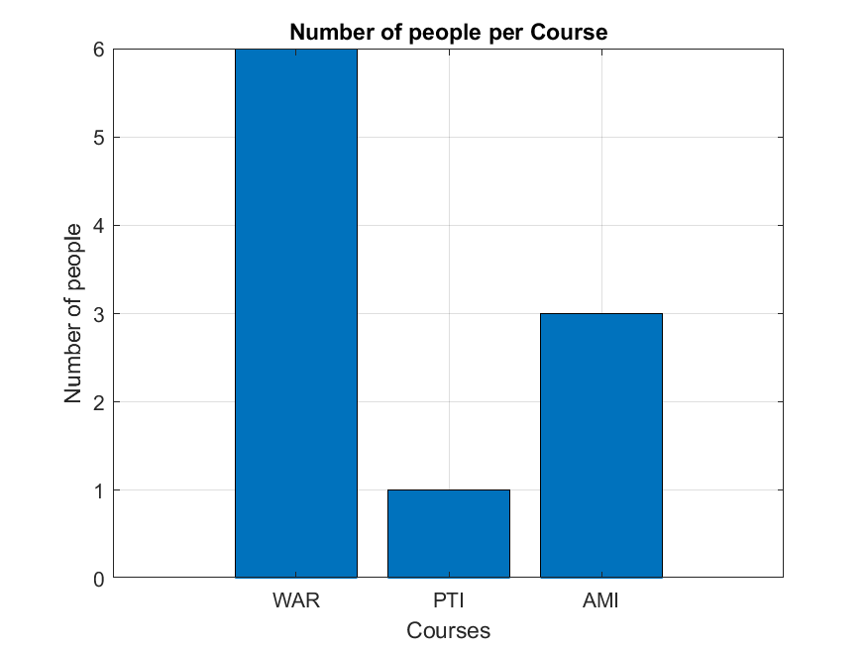

This creates and displays data for given elements; it specifies X and Y directions i.e. Courses against number of people.

X = [22,25,23,22,21,22,21,25,21,22];

Y = sin(X);

plot(X,Y,'g--');

hold on

Z = cos(Y);

plot(X,Z,'K-O');

xlabel('Age')

title('Age distribution')

grid on;

hold off

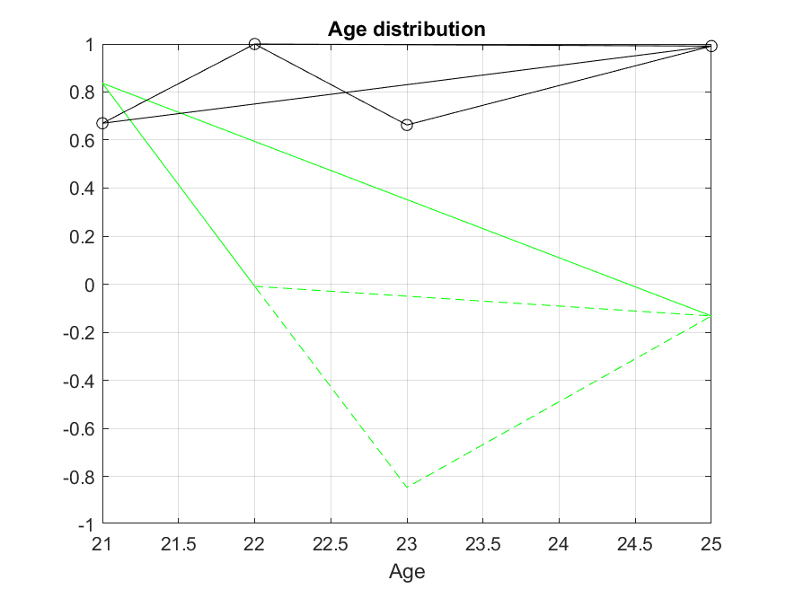

x = [22,25,23,22,21,22,21,25,21,22];

[x,y] = meshgrid(x);

z = sin(x) + cosh(y);

waterfall(x,y,z);

xlabel('Age');

ylabel('y');

zlabel('z');

title('Age distribution plot')

**A WATER FALL PLOT FOR AGE DISTRIBUTION**

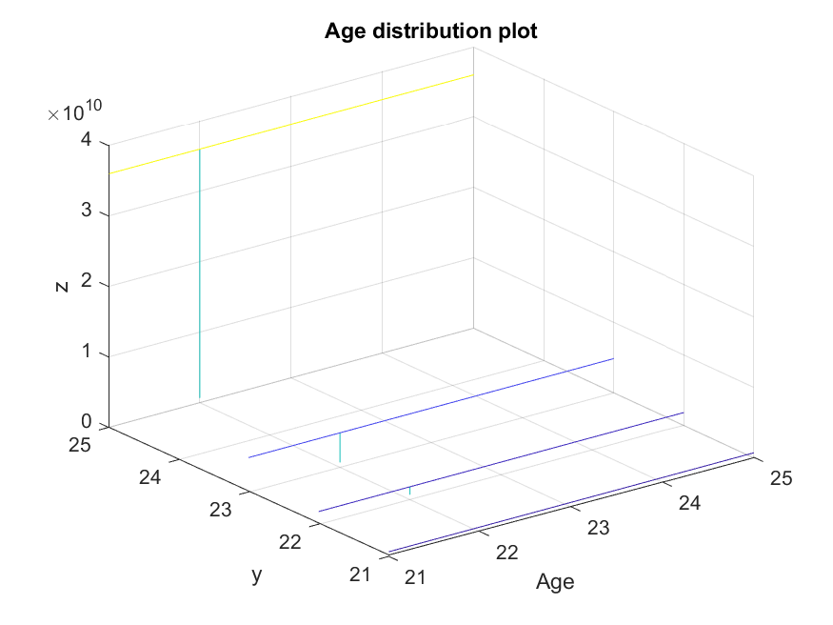

A waterfall plot is a mesh plot with a partial curtain along the Y dimension.

It plots the heights above the grid in the XY plane defined by X and Y i.e. Age distribution.

x = [22,25,23,22,21,22,21,25,21,22];

y = exp(x);

semilogx(x,y);

xlabel('Age');

ylabel('exp(x)');

title('Logarithmic plot of Ages')

grid on

**A LOGARITHMIC GRAPH OF AGE DISTRIBUTION**

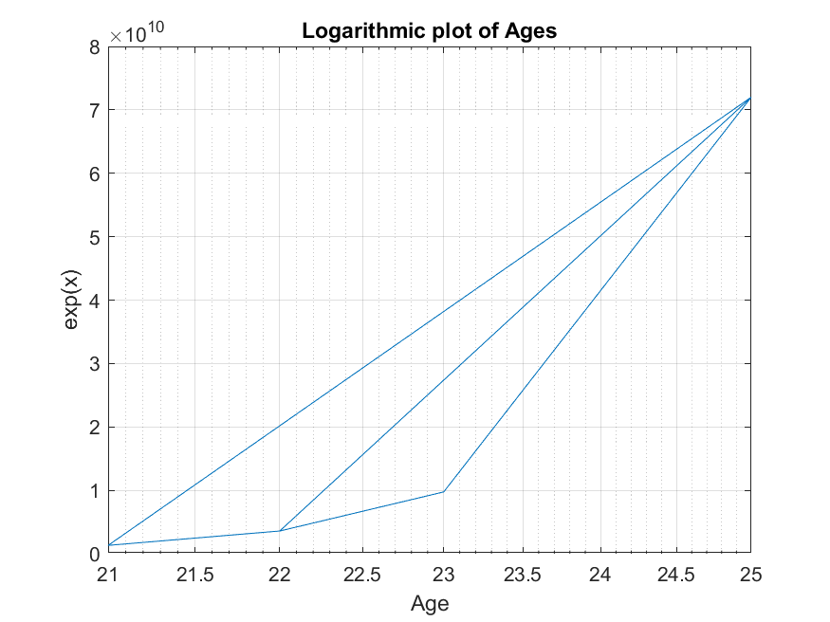

A logarithmic graph plots x and y co-ordinates using the base 10 logarithmic scale on X and Y axes.

Ages = [22,25,23,22,21,22,21,25,21,22];

heatmap(Ages);

title('heat map for students age distribution');

**A HEAT MAP FOR STUDENTS AGE DISTRIBUTION**

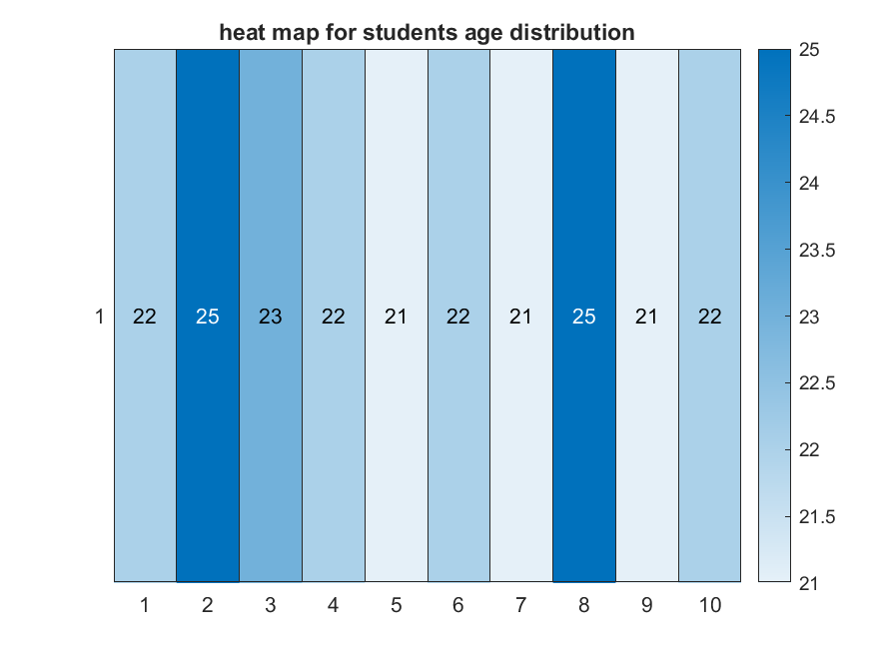

A heat map is a graphical representation where values are visualized by color intensity.

## CHAPTER THREE:

# 3.1 CHALLENGES

* Limited time given for the assignment to be completed.
* Referencing errors at times made the work hectic
* Lack of concentration due to the different course units being handled at the same time

# 3.2 RECOMMENDATIONS

* We recommend that the lecturer to always give us ample time to complete the assignment.

# 3.3 CONCLUSION AND LEARNING EXPERIENCE

Upon assignment completion, we really appreciated the MATLAB especially from the introduction part to the coverage. This embedded a real-life application of the software into the different engineering aspects. We gained a deeper rhythm on how to visualize data on different plots, structural arrays, matrix presentation and so many. This experience was utmost to all of us.